20/03/2020

Trying to clarify my mind:

**BEF**.

🡪 **Complementarity** and **selection** effects can explain a positive relationship between SR and ecosystem functioning (in controlled experiments – use of Loreau-Hector partitioning).

🡪 Environmental heterogeneity should affect the BEF relationships, directly (abiotic filter reduces the number of species) and indirectly (biotic filter: interactions between species expand or reduce the niche, and can impact ecosystem properties).

🡪 **MRH Grime** / **Keystone species** (effect disproportionate relative to their biomass): two opposite kinds of expectations. Functionally rare species can have an important biomass (and consequently they cannot be keystone species), and hav a strong impact on ecosystem functioning. See the concept of “key” species (Eva Maire ?).

**Niche theory**. Coexistence (stabilizing niche differences and fitness differences). Depends on the traits – multi-functionality.

**Traits**: response, effect. Functional traits: effect on performance (morphology 🡪 performance 🡪 fitness).

What history can I tell?

BEF relationships have been shown in a variety of experimental (and observational?) settings. There is an effect of richness, but also of composition. Disentangle both. Grime MRH suggests that some species have a stronger effect than others, and that this is proportional to their abundance.

Not clear whether rare species can have a strong effect. Define functional rarity.

Interest of removal experiments to see the contribution of some species (papers cited in Turnbul, 2016).

Manipulative experiments: not enough environmental heterogeneity. On the contrary, real-world prevents from manipulating (particularly long-term removal experiments) 🡪 correlative (Eva Maire). Here we have a model which explicitly takes into account competitive interactions between species. Useful setting to test biotic interaction effects.

21/03/2020

Stress effects on BEF: stress modifies intra and interspecific interactions. Environmental variations must be taken into account for BEF studies. To be added to the assembly processes (CAFE). All of this is linked to niche theory.

Interestingly, when trying to explain BEF relationships, we have to go into the competition/facilitation literature. The underlying ideas are:

* Biotic interactions (either positive or negative) modify specific productivities (among other properties), and these properties sum up to ecosystem functions.
* Environmental heterogeneity modulates inter (and intra)specific interactions.
* Consequently, the traits of the species still matter for explaining BEF relationships, but this is theoretically expected to be context-dependent.
* This is what we observe in our simulations (i.e. different results for Bever and Bern).
* This context-dependency can be described using chain-rule decomposition, to analyze the effects of continuous (small) environmental changes on ecosystem functioning. In which cases might this framework be appropriate: global change seen as incremental changes in temperature? Local spatial heterogeneity in the field (but there is no reason why it should be continuous...)?
* In addition to a richness effect (which might or might not be a general rule), we thus expect that composition will affect ecosystem functioning, either by positively or negatively impacting species-level properties. These interactions need not be pairwise, but might be more accurately described as an “interaction milieu” (sensu McGill, 2006), i.e. a biotic background.
* We can quantify the effect of interspecific interactions using the comparison with monocultures. When we remove a given specie, if the amount of ecosystem property lost is higher in the mixture than in the artificial community made of aggregated monocultures, we can deduce that this specie positively affects the performance of the other species (and vice-versa). But how can we make these comparisons efficient? Quantify the drop in ecosystem property when we remove a given species, and see if it correlates between the mixture and the monocultures ? If it does, it means that when we remove a good performer, it reduces the ecosystem property accordingly. If it doesn’t, i) if the removal of a good performer is compensated by an increase of the property of other species, we can deduce that the good performer was also a good competitor; ii) if the removal of a poor performer (the quantification of “performance”, i.e. amount of ecosystem property, is made on the monocultures) reduces the ecosystem property more strongly than expected based on his amout of ecosystem property, we can deduce that this species acted as a facilitator.
* We can quantify the algebraic discrepancy between the amount of property expected to decrease when we remove a species based on its monoculture and the real decrease in the mixture. If this discrepancy is negative, it means the removal of this specie reduced the ecosystem property more than expected. The specie is thus important for ecosystem functioning (could it be considered as a facilitator? Maybe not, because we don’t know the effect it has on other species’ fitness, but it is clearly linked). We expect that this kind of species will be more common amongst the functionally rare species.
* Can we also use the CAFE framework? We could use it on both types of cultures (mixed monocultures and mixture), and see if the SIE.L correlates between the two cases (and the CDE too). First, I need to build the aggregated monoculture in a way that makes sense (see M. Chauvet’s PhD).
* What matters for ecosystem properties is individuals, more than species (🡪 Chris’ framework focuses on individuals). However, species, not individuals, are evolutionary units capable of allele transmission (at least for pluricellulars). 🡪 What then?

22/03/2020

Graphs with the same x scales (some species are thus lacking from the Mixture, i.e. right-side, panel).

C:\Users\Weemstra\Documents\Stage M2 Léo\Project 1_distinct sp_BEF\figures\Monocultures_Bern\Di~biomass_Mixture.tiffC:\Users\Weemstra\Documents\Stage M2 Léo\Project 1_distinct sp_BEF\figures\Monocultures_Bern\Di~biomass_Monocultures.tiff

Complete mixture (will all the species that remain at the end of the simulations):

C:\Users\Weemstra\Documents\Stage M2 Léo\Project 1_distinct sp_BEF\figures\Monocultures_Bern\Di~biomass_Mixture_Complete.tiff

So the relative biomasses are relatively continuously distributed in monocultures, whereas there are few dominant species in the mixture, and all the other species have a low biomass. There is a strong competition effect.

* Just to keep that point clear: we cannot predict how much the total biomass will be affected by removing a dominant species from a monoculture, because that species may be a good competitor whose niche, when left vacant, is filled by other species. (Consequently, we need to make another simulation without that species to know the new total ecosystem property level.) Can we say that this simulation framework provides a holistic way of considering a community?
* Some species perform well, and they are important for ecosystem functioning seen as an aggregate property (in this case because they have a hudge biomass). If removing such a species makes the ecosystem property drop, it means that no other species can use its niche (and thus its good “performance” was not due to competition, but rather to local adaptation, which can be checked in the monocultures). A theoretical prediction is that it will happen more often in stressful environments, in which performing well might require specific adaptations. If, in addition, this species is functionally rare, we are in the case “Dominant distinct traits”. 🡪 This is one important possible effect of functional rarity on ecosystem functioning: **some environments might require specific adaptations that are only borne by functionally rare species (such as Pinus cembra in Bever). In this case, rare species are important because they occupy a niche that would otherwise be empty.**
* But we also expect competition/facilitation effects. Are functionally rare species good competitors ? In this case, there would be no drop in the ecosystem property when we remove them, because their loss would be compensated for by an increase in other species’ property. (This is true for an additive property. In case of an emergent property... I have to think about it, but I guess the reasoning will be different. See the literature on the insurance hypothesis too).
* In the case of facilitation, removing a species would lead to a drop in biomass that would not be compensated. But how to separate this case from the “Dominant distinct traits” case explained above? We predict the same results for both. Here, the CAFÉ approach could be useful ,because it could tell us whether the species that was removed was a good performer (case “Dominant distinct traits” ) or not (species that acts as a facilitator to other species).

I should make the same graphs for both orders of species removal, and for all the numbers of species left. Should I then make pairwise comparisons? Or is there a more efficient way?

I could also look at which traits make some species good competitors, and how it correlates with the environment. How can I do it?

23/03/2020

All the reasoning was oriented towards a specific case of aggregate property: total biomass. Does it holds for other aggregate properties (such as productivity)? I need to have java installed to run other simulations with productivity as output, and with monocultures in all the environments.

I looked at the comparison between the monocultures and the mixtures for each number of species removed, when removing by decreasing order of distinctiveness. One interesting case is the following:

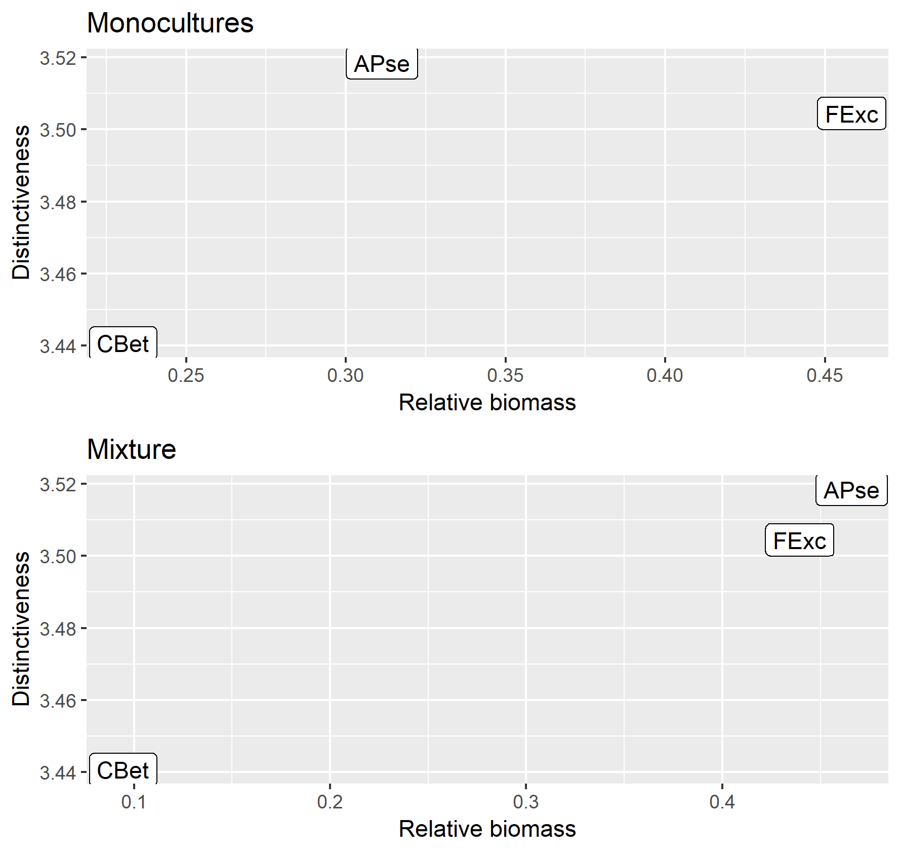

The relative biomass of Apse is higher in the mixture than in the monoculture. Might there be a phenomenon of facilitation? Or is it just that there is competition that reduces the biomass of Cbet, thus increasing Apse’s relative biomass?

I can look at the data for simulation 28 (this one).

species mixture(t/ha) mixture\_relative monoculture(t/ha) monoculture\_relative Di

1 APse 109.1468 0.46600911 155.4652 0.3113083 3.518458

2 CBet 22.1321 0.09449436 114.9932 0.2302661 3.440727

3 FExc 102.9371 0.43949653 228.9345 0.4584256 3.504452

It’s the second option: Apse increases in relative biomass in the mixture because the reduction in the biomass of Cbet is higher than the reduction for the two other species.

What can I say from these graphs? Should I look at the decrease in absolute biomass, to see which species fare better than average in mixture? I can make the ratio: (biomass in monoculture – biomass in mixture)/biomass in monoculture, for each species and for each simulation number.

When I do that, we see that most species loose almost all their biomass when put in a mixture (see the histogram below). The ones that loose less than average are... the ones that have the highest relative abundance in the mixture. But it doesn’t tell me much.

